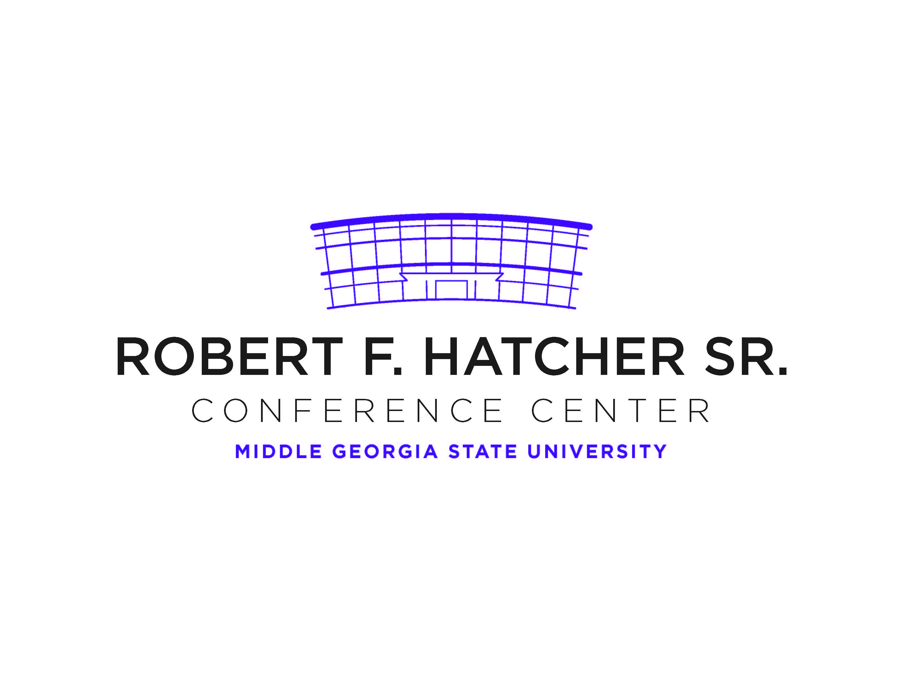**TEMPORARY PARKING PERMIT**

***VALID DATE: January 24, 2020***

**SCIE Spring Meeting**

DO NOT PARK IN FACULTY/STAFF PARKING AREAS.

DO NOT BACK INTO SPACE

DISPLAY PERMIT ON DASHBOARD OR REAR WINDOW

Smoking is prohibited on campus