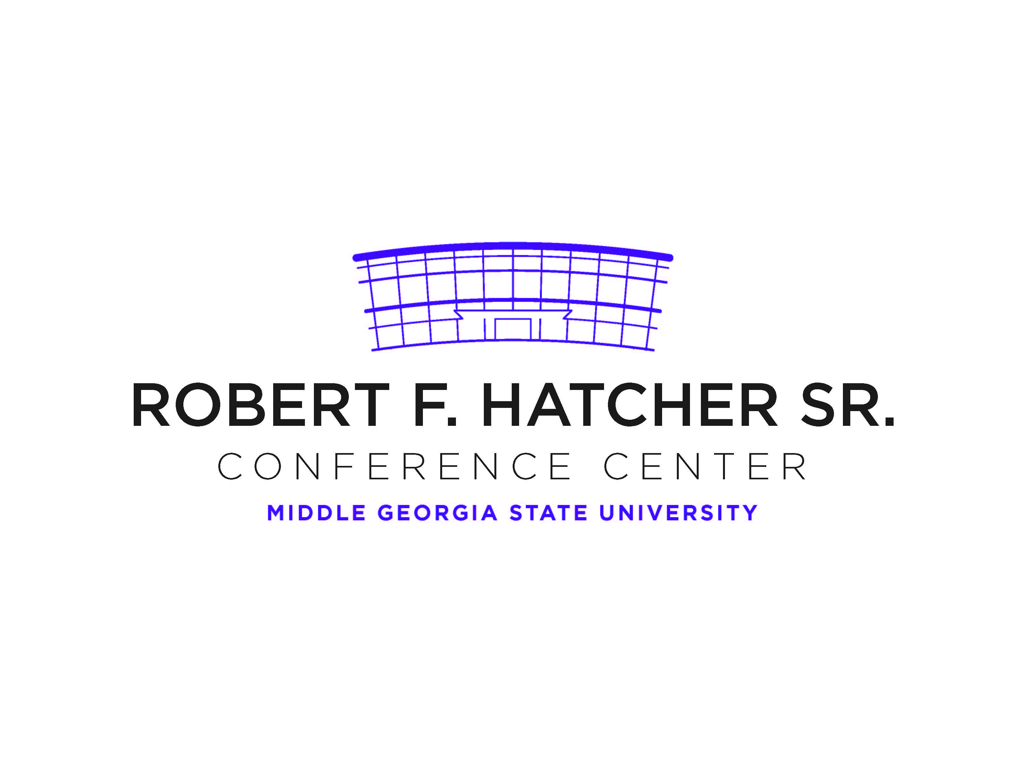**TEMPORARY PARKING PERMIT**

***VALID DATE: September 20, 2019***

***SCIE Fall Meeting***

DO NOT PARK IN FACULTY/STAFF PARKING AREAS.

DO NOT BACK INTO SPACE

DISPLAY PERMIT ON DASHBOARD OR REAR WINDOW

Smoking is prohibited on campus