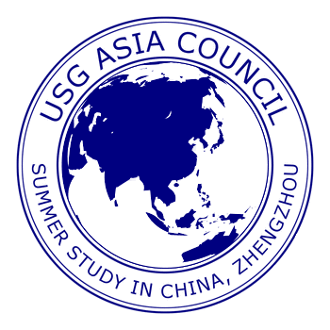

USG Asia Council

Call for Faculty Participation

2020 Summer Study Abroad in China—General Studies Program

May 8–June 5, 2020

The 2020 Summer Study Abroad in China program is inviting USG faculty members to teach for the program between May 8 and June 5, 2020. The program is sponsored by the Asia Council of the University System of Georgia (USG), and is open to all students and faculty of USG institutions. The program is hosted by Zhengzhou University in Henan Province. Zhengzhou is Henan’s capital city with a population of more than seven millions. The program’s itinerary also includes visits to some well-known cultural, historical and geological sites in Beijing, Xi’an, Dengfeng, Luoyang, and Shanghai.

The 2020 program is looking for faculty members who are able to teach two undergraduate courses at lower and/or upper divisions. All fields will be considered, except science courses involving labs. Course delivery and learning assessments such as examinations and assignments are to be comparable to those required in regular classes taught at a USG institution. Please visit the program website at http://acchinaprogram.org/ for examples of prior courses and related information. The deadline to apply for the 2020 program participation is April 2, 2019. A faculty guide concerning terms and conditions of participation is available upon request.

Since the program is financially self-supported, faculty members are expected to engage in active student recruiting. The minimum recruiting target is six students per faculty, although there is some flexibility on the quota depending on the overall student enrollment figure. The program will provide color-printed posters and brochures to participating faculty for student recruitments.

The program will cover participating faculty’s travel costs, which include round-trip airline tickets to and from China, domestic transportation in China, lodging, entrance fees to cultural sites, and group meals. The program will also provide faculty with per diem compensation for the period of program operation in China. The program, however, will not cover summer teaching stipend. Faculty members can negotiate with their home institution on their summer stipend. Most institutions will provide this kind of stipend based on certain formulas. A faculty’s spouse may travel with the program but needs to pay the cost of all travel-related expenses.

If you are a full-time faculty member at a USG institution, and are interested in teaching for the 2020 China program, please contact the program’s directors.

Dr. Baogang Guo (Program Director) at (706) 272-2678 or email:
bguo@daltonstate.edu

Dr. Wilson Huang (Program Co-director) at (229) 333-5486 or email:
whuang@valdosta.edu

