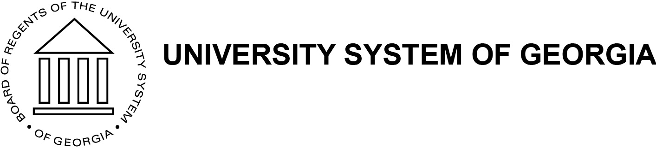

ASIA COUNCIL MEETING
Friday, 25th January 2019
Middle Georgia State University Conference Center, Room 239B

Agenda:

- Approval of Minutes
- Old Business
- New Business
  - Summer Study Abroad Program Updates
  - Changes and New Regulations to Agency Accounts
  - Spring 2019 Faculty Development Workshop
  - Spring 2019 ASDP (Asian Studies Development Program) Meeting in Nashville
  - Spring 2020 ASDP Annual Meeting (Co-hosted by us, the Asia Council) in Atlanta
  - Updating Roster of Active Members
- Other business?

