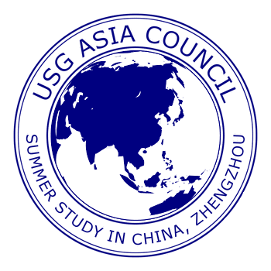
ASIA COUNCIL OF THE UNIVERSITY SYSTEM OF GEORGIA
Summer Study Abroad in China — General Studies Program
May 10– June 7, 2019

Faculty Application and Course Proposal Form
APPLICATION DEADLINE: March 26, 2018

Instruction: Please fill in the form by using MS Word, and use this form to process signatures for approval. After authorized administrators have signed the form, send it to the following address along with a three-page vita: Dr. Wilson Huang, Co-Director of USG Summer Study in China, Department of Sociology, Anthropology, and Criminal Justice, Valdosta State University, Valdosta, GA 31698-0060

- Faculty Information

Title: Dr. Mr. Ms. Mrs.
Name: Last: Middle: First:
Institution:
Academic Rank: Professor Associate Professor Assistant Professor Other ______
School Mailing Address:

Email Address:
Phone: Fax: Cell Phone:
Home Address:
Home phone: Home fax:
Home Email:

- Course Information
Course One Title:
Prefix and number: Credit hours:
Description (a brief, one paragraph description to be used for program brochure, including possible field trip sites. This is the main information students will have in deciding whether or not to sign up for your course. 100-word maximum):

Level: lower division upper division

Course Two Title:
Prefix and number: Credit hours:
Description (a brief, one paragraph description to be used for program brochure, including possible field trip sites. This is the main information students will have in deciding whether or not to sign up for your course. 100-word maximum):

Level: lower division upper division

- Faculty Commitment

“I understand that my participation in the Summer Study Abroad Program in China is dependent on enrollment of six (6) students from my campus in the summer 2019 Study Abroad Program in China. If I am accepted to teach in the Program, I understand further that teaching in a summer study abroad program is an intensive and comprehensive experience, involving faculty members with students in many out-of-class activities. Therefore, I understand that I will be obligated not only to teach formal classroom sessions but also to accompany students on scheduled fieldtrips, assist students in planning course-related independent travel, and collaborate with other program faculty and students in scheduling and conducting joint activities. I understand further that the demands on faculty, the group living arrangements, and the program schedule generally do not accommodate dependent children, although there are exceptions in some of the programs. Prospective faculty members should consult the appropriate program director to determine whether children under 18 can be accommodated at a particular site. By signing below, I indicate that I have read and understood all of the above information.”

_____________________________________________ ___________________
(Faculty Signature) (Date)

- Approvals and Signatures from Campus Administrators. By signing below we, the undersigned, understand the terms of this agreement and support the faculty member’s participation in this program.

______________________________________________  (Asia Council Campus Representative or director of International office) | _____________________  Date
_________________________________________  (Department Chairperson) | _____________________  Date
______________________________________________  (Dean) | _____________________  Date
______________________________________________  (Chief Academic Officer) | _____________________  Date

