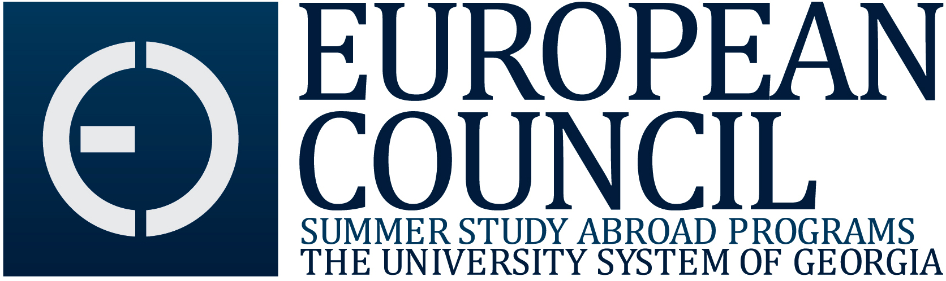

MEMORANDUM OF AGREEMENT FOR PRIVATE INSTITUTIONS

- Introduction

The European Council (EC) is one of five regional councils operating under the auspices of the System Council for International Education of the University System of Georgia (USG). The EC seeks to foster greater understanding and appreciation of the cultures and societies of Europe by sponsoring summer study abroad programs and activities. Membership of the EC is limited to USG member institutions. Institutions of higher education that are not unit institutions of the USG may, upon an affirmative vote by the EC membership, enter into an EC Memorandum of Agreement for Private Institutions that allows participation of both students and faculty in all EC programs. The EC is committed to the joint development and sponsorship of faculty and student study abroad programs in and related to Europe.

- Private Institution Membership

  - Eligibility. Any private institution that has its principal physical campus within the State of Georgia may enter into this memorandum of understanding. The MOU remains in effect for a period of three calendar years.

  - Rights of Membership. Each non USG member institution is entitled to the following:

    - to designate an official EC representative who will serve on the Council in a non-voting capacity;
    - the nomination of faculty to be considered to teach in the study abroad programs of the EC;
    - enrollment on its campus of students in course offerings of EC
study abroad programs;
    - receipt of tuition monies from students enrolled for credit in EC summer study abroad programs through the institution.

  - Obligations of Membership. Private institutions commit themselves to the following:

    - publicizing opportunities for faculty to participate in EC programs, including seminars and study abroad activities, and assisting faculty in applying for these opportunities;
    - promoting EC study abroad programs on their campuses and actively recruiting students for these programs;
    - establishing equivalencies for courses offered through EC programs and implementing procedures for their students to register for these courses;
    - advising and counseling students on procedures they must follow to enroll in EC programs, apply for financial aid, and register for courses;
    - establishing a process by which students will register for academic credit and pay tuition and overseeing the implementation of that process;
    - collecting and verifying as accurate and complete all applications from their students for EC study abroad programs and forwarding applications to the EC office at Valdosta State University;
    - informing the EC office at Valdosta of any reasons why a student may be ineligible for participation in a study abroad program of the Council;
    - assuring that student grades are accurately and promptly entered into the record-keeping unit on the campus as soon as these grades are received from the EC offices;
    - assisting the European Council in collecting delinquent fees owed by their students for participation in student abroad programs, through the placement of holds on students’ academic records or through other appropriate means;
    - establishing policy for payment of the institution’s faculty
who teach on EC programs.

- Withdrawal from Membership

Institutions may withdraw from the agreement six months after submitting a written intention to do so to the Chair of the European Council, provided that any and all outstanding obligations of membership, as specified in B.3 above, have been met.

- Statement of Affirmation

Agreement with the intent, terms, and obligations of membership in the
European Council, as set forth in this memorandum of agreement, as well
as the intention to comply with the intent, terms, and obligations of
membership, is affirmed on behalf of the institution named below by the
signature of the person named. The signing of this memorandum does not
imply, either for the individual person or the institution that person
represents, any assumption whatsoever of liability for any damages
incurred to persons or property as a result of the activities of the
European Council.

For the Private Institution

______________________________ __________________________________
Name of Member Institution Name of EC Representative

______________________________ __________________________________
Name of Chief Academic Officer Signature of EC Representative

______________________________ __________________________________
Signature of Chief Academic Officer Date

______________________________
Date

______________________________
Name of President

______________________________
Signature of President

______________________________
Date

For the European Council

_______________________________
Name of EC Chair

__________________________________
Signature of EC Chair

__________________________________
Date

