Japan Workshop – Getting There

Location: Georgia State University – Perimeter College, Dunwoody Campus (formerly Georgia Perimeter College, Dunwoody Campus)

The campus is located approx. 18 miles Northeast of Atlanta just outside the I-285 Perimeter, three exits from I-85 (a.k.a. Spaghetti Junction) – More detailed info below.

Address: 2101 Womack Road, Dunwoody, GA 30338

Contact: Eric Kendrick, 404-717-7695 (mobile)

MAP & DIRECTIONS (link to GSU website on program flyer – Click PARKING & MAPS link) - More detailed info below.

Closure: Due to the interstate collapse of I-85 just north of downtown, the interstate is closed at this area. If coming from the south, DO NOT TRAVEL THROUGH DOWNTOWN ATLANTA. If so, you will be directed to congested alternate routes. Rather, take I-285 around the city. Those coming from up I-75 can take I-675 for a more direct route to I-285.

More Specific Directions

From 85 Driving South – Take 285 East (toward 75 & Chattanooga) to Exit 30 (3rd Exit)

From 285 Driving North / West (i.e. driving up 75 North from Macon and 675) – Drive through 85 intersection (Spaghetti Junction) & take Exit 30 (3rd Exit)

For both of the above:
1st exit past Spaghetti Junction (85 & 285 intersection) is Buford Hwy
2nd exit is Peachtree Industrial
3rd exit – EXIT 30 – is for Dunwoody Campus
Exit 30 sign says North Peachtree Road / North Shallowford Road / Chamblee-Dunwoody Road -- as the access road leads to all three of them.
At end of exit ramp, Turn Right onto the first road: North Peachtree Rd (gas stations on both corners)

From 75 South -- Take 285 East (toward 85 & Greenville) to Exit 30
As you’re getting closer, you’ll pass Hwy 400 and Peachtree Dunwoody Rd (Perimeter Mall).
After that, take Exit 30 (sign says Chamblee-Dunwoody Rd., North Shallowford Rd., North Peachtree Rd.)
Go straight at top of exit ramp (cross Chamblee-Dunwoody Rd)
Pass through North Shallowford Rd. (will pass Wendy’s on right)
Turn Left onto North Peachtree road (will pass under 285) – headed North (gas stations on both corners)

Since I-85N is shut down for a distance from downtown until before you get to the midtown area those of you coming from the South could use one of two routes listed below:

Route 1

Take I75N to I675N to I285N and follow instructions from # 8 in route 2.

Route 2

Take I75N and exit at 216 and follow the instructions below if you would like to avoid the busy I675N stretch.

Turn right onto Highway 155 N/GA-155.
Then 3.76 miles Enter next roundabout and take the 2nd exit onto GA-155.
Then 6.07 miles Stay straight to go onto Snapfinger Rd.
Then 1.78 miles Turn right onto Wesley Chapel Rd.
Wesley Chapel Rd is 0.2 miles past Pleasantwood Dr
Then 0.38 miles Merge onto I-20 W/GA-402 W via the ramp on the left toward Atlanta.
Then 1.09 miles Merge onto I-285 N/GA-407 N via EXIT 67B toward Greenville/Chattanooga.
Then 15.73 miles Take the N Peachtree Rd exit, EXIT30, toward N Shallowford Rd/Chamblee-Dunwoody Rd.
Then 0.27 miles Turn right onto N Peachtree Rd.
Then 1.14 miles Turn left onto Tilly Mill Rd.
Tilly Mill Rd is just past Peeler Rd (If you reach Welton Pl you've gone a little too far)
Then 0.60 miles Turn left onto Womack Rd. Womack Rd is just past Tillingham Ct (If you reach Dunwoody Gln you've gone a little too far)

From 285 coming up 85 from South of Atlanta
Follow the same directions above from 75 / 285 intersection (near new Braves Stadium)
FROM ALL OF THE ABOVE – ONCE YOU’RE ON NORTH PEACHTREE ROAD
Travel north approximately 1.1 miles.
Turn left onto Tilly Mill Road (intersection with red light) just after large Episcopal Church and small Anglican Church on right and county park on left
Continue approximately 0.6 miles.
Turn left onto Womack Road / Campus Entrance on Left
You’ll circle the campus, which is very short

Sidewalk Construction

There is some sidewalk construction at the Intersection of North Peachtree and Tilly Mill (where you turn left on Tilly Mill). It was supposed to begin Friday evening, but work had started as of Thursday morning. Since less students are on campus Friday, it should have great affect (maybe an extra 5 minutes at the intersection). However, if you’re good with directions, you might consider this:
Coming from 285 headed West – after Spaghetti Junction (85 and 285)
Take the 2nd exit onto Peachtree Industrial – headed North) instead of the 3rd (North Peachtree) o Take the 1st exit to Tilly Mill Road (it will say GA Perimeter College) and turn Left (headed west) o Go through the Tilly Mill / North Peachtree intersection and continue on to Dunwoody Campus
as noted above (you’re still going through the sidewalk intersection, but without the left turn; also, less traffic comes from this direction).
Coming from 285 headed East
Go one additional exit to Peachtree Industrial, and exit heading North
Follow the same directions above

From Hotels around Perimeter Center
Peachtree Dunwoody Road (across from mall)
Continue driving north on Peachtree Dunwoody (away from 285)
Shortly past Wal-Mart, turn Right onto Womack Road (this will take you all the way to campus)
• GA-400
If you’re good with map apps, you can take the back way to campus along Mt. Vernon Rd.
Call Eric Kendrick (404-717-7695) if you need any assistance).

Parking
On Friday, Lot 9 (faculty/staff) directly in front of connected NC-ND buildings, may be available (small lot). If not, use adjacent Lot 8 or Lot 10, which will have space.
We’ll be in the NC-ND buildings (connected)

Campus map attached

l•Georgia Perimeter College
00
Welcome to the
DUNWOODY CAMPUS
Georgia Perimeter College 1s tobacco-free and smoke-free. Please visit tobaccofree.gpc.edu for additional information.

NC
Auditorium
Concessions-Campus cafe Dental Hygiene V
Testing Center

ND
Faculty Offices Foreign Language/ESL Nursing

Lot 6 Student Parking

Lot 7
Il
Faculty/ "
Staff Parking

Observatory
l

T•nil
Court1

Soccw
Field
NE
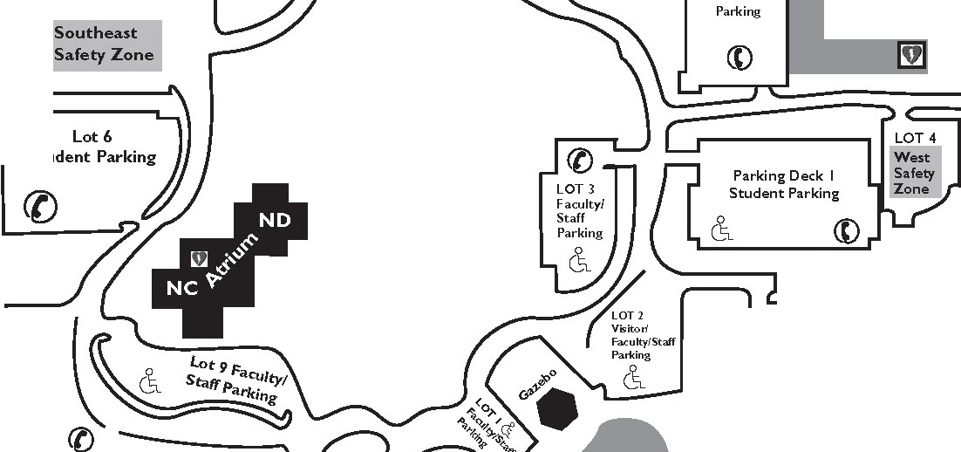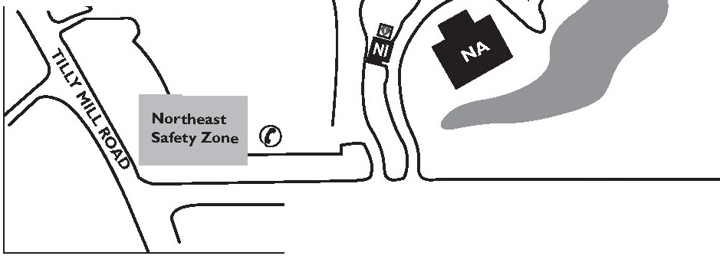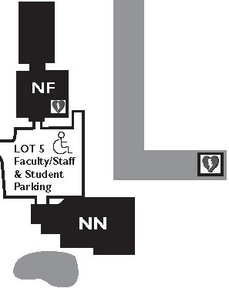Business Computer Lab Computer Science

Legend
9 Automated External Defibrillator Ill Emergency Phone
<:'\.. Handi cap Parking

Engineering English
Faculty Offices

c

CD «l
... c..
0 ...
...J c
"C"l
"

Lot 10 Student Parking
II•

WOMACK ROAD

LOT I I
Student Parking
History and Political Science Honors Program
Humanities and FineArts
JagSPOT and Computer Lab Mathematics
MediaSPOT
Science

NF V Lobby
Gymnasium
Ki nesiology and Health Physical Education Weight Room
Wellness
N
NI
Public Safety Administration V
Parking Permits

LRC
Leaming and Tutoring Center Leaming Resources Center (Library)

NA
Deans of Academic and Student Services
Disability Services
Dual Enrollment Faculty Offices

NB
Admissions
Advising, Counseling & Retention Services
Bookstore Campus cafe

ID Card UCard ) Services International Student Services Military Outreach
Public Safety V
Student Accounts and Cashier

NN
Facilities Operations

NT
Student Health Center V

Technology and Media | Enroll ment & Regi stration Services | Student Govemment Association
 | Financial Aid | Student Life | 15-08-069

